## Real Time Sign Language Recognition using Transfer Learning

G Harshavardhan1, G Harshavardhan Rao2, Harshith S3, G Anil Kumar4, G Srikanth Reddy5

*Research Scholar1,2&3, Associate Professor4&5, Department of Computer Science and Engineering,*

*Vignana Bharathi Institute of Technology, Hyderabad, Telangana, India.*

*E-mail id a)*[*ghvy999@gmail.com*](mailto:ghvy999@gmail.com)*, b)*[*hv5744577@gmail.com*](mailto:hv5744577@gmail.com)*, c)suryawanshiharshith@gmail.com*

Abstract *-* Humans depend heavily on communication since it gives us the ability to express ourselves. Speaking is one of the most prevalent ways we communicate, along with body language, gestures, reading, writing, and visual assistance. Sadly, there remains a communication gap for the minority who are speech and hearing impaired. Deaf and mute persons can learn sign language, which is typically unknown to hearing people. It occurs to us that communication should be made simpler in order to eliminate the communication gap between hearing-impaired people and the general population.

To get over this obstacle, we suggest a technique in which sign language movements are gathered using a webcam and trained a Tensor Flow model using transfer learning to construct a Real-time Sign Language Recognition system. Many individuals will benefit from this when trying to communicate with the deaf and the mute.

*Keywords - Sign Language Recognition, Transfer Learning, Tensor flow, Deep Learning, Python.*

# **Introduction**

Sign languages are one of the means of communication when spoken language cannot be used, body language, particularly with the hands and arms, is one option. Sign languages are one of these methods. For the deaf and mute communities, it has evolved into the primary means of communication. In order to break down this communication barrier between sign language users and those who utilise spoken language. We have presented a deep learning model that makes advantage of the well-liked transfer learning method.

People who are deaf or dumb find it difficult to connect to computers at work since they can't hear them. Being unable to hear automobiles, bikes, or other people coming makes it unsafe to go alone. They take a while to adjust to their surroundings and other people, and finding one's voice is challenging. Western societies have used sign language as a visual language or method of communication since the 17th century. Sign language is composed of conventional motions, impersonations, hand signals, figure spelling, and the use of hand position to symbolise the alphabet. A sign can sometimes stand in for a complete idea or claim.

The main objective is to provide speech and text output for deaf people via hand gestures.Sign language using a sophisticated way without any sensors.

# **LITERATURE REVIEW**

In order to complete the project, we conducted a domain study that was primarily focused on comprehending neural networks.

**TensorFlow:**

TensorFlow is a free and open- source software library for dataflow and differentiable programming across a range of tasks. It's a  emblem calculation library, it used for both exploration and product at Google. Tensor Flow provides stable Python and C. Third- party packages are available for C#, Julia, and Crystal. New language support should be implement on C API, not all functionality is available in C yet. Some further functionality is handed by the Python API.

Tensorflow is free open source library with emblem calculation data flow. Operations for which TensorFlow provides are automated image capturing and evaluation.

**OpenCV:**

OpenCV is a library of programming functions mainly at real- time computer vision. Firstly developed by Intel, it was latter supported by Willow. The library is third party-platform and free for use under BSD license.

**Joudaki & Rehman**( 2022) proposed a Geometric Neural Network model to fete the sign language ABC. These cameras capture hand movements. Project design has colorful operations. This system exploits rates that are harmonious anyhow of hand movement. Precise hand movements can ameliorate a neural network's recognition delicacy. It may also fete the baby’s sign language.

**Mohammed and others** (2022). In a depth picture, the hand region was located and separated using the Microsoft Kinect detector. This approach works well when the hand and skin's tones match the face's. Convolutional neural networks (CNN) are utilised in this instance to automatically induce ISL features. The system can correctly read ISL foundations in real-time since the model redounded in 99.3 delicacy.

Using deep literacy models, a grade- grounded optimizer, and optimisation hyper parameters,**Sharmaetal.'s** stationary identification of Indian sign languages was investigated in 2021. Using a specially created three layered CNN model and a closely accessible ISL dataset, the elegant number and ABC recognition delicacy were independently 99.0 percent and 97.6 percent. 96.2 percent of the time, the ISL dataset correctly recognised integers.. The ISL dataset rightly detected integers96.2 percent of the time and rudiments90.8 percent, outperforming other-trained models.

# **PROPOSED METHODOLOGY**

Using our proposed model transfer literacy system, we should design a system that uses apre-trained model. A Computational Neural Network been saved after trained on a big dataset, is known as pre-trained CNN model. We can moreover use the pretrained model as is, or we can acclimatize it to any task via transfer literacy. It enables real- time bracket on mobile bias with limited processor speed, similar as smartphones. The dataset is subordinated to ImageNet transfer literacy using this strategy. A model that has been trained on a large dataset may be suitable to serve as a general frame of the visual world.

**TRAINING MODULE:**

Supervised machine literacy is one of the model is trained by input data and anticipate data. It necessary to follow below processess.

1. Creation

2. Training

3. Testing

4. Evaluation

**Model Creation**:

It depends on machine literacy algorithms. Neural networks were used in this research.This is how an algorithm appears

1.Start with its subject succession model()

2.Next,comprise layers with different types.

3.The model is assembled formerly there are enough layers added. TensorFlow and Keras are presently in communication in order to make the model.

The loss function displays perfection of each vaticination the model made.

**Model training:**

In this phase, input datasets are trained and affect anticipated affair. At the end report with final delicacy of the model.

**Model testing:**

This stage involves loading a alternate piece of data. The delicacy of the model will be verified as it has noway seen this set of data. When the model training is finished and it's determined that the model predicts the correct outgrowth, it may be saved with the commandmodel.save("name_of_file. h5"). The stored model can also be applied in real life. Model evaluation is the name of this stage. As a result, the model may be applied to the evaluation of fresh data.

**Preprocessing**:

**Aspect rates**:

A proportional connection between an image's range and height is known as an aspect rate. If the picture were 1500px by 1500px or 500px by 500px, the aspect ratio would remain 11. Another example would be a portrayal-style image, which might have a pace of 23. The height is 1.5 times longer than the range when aspect rate is used. So, the picture will be 500 px by 750 px, 1500 px by 2250 px, etc.

**Cropping to an aspect rate**

For illustration, if you use images that have same aspect rate, they'll each crop the same way on your point.

Option 1- Use the Image Editor to crop images to a specific shape. Use the crop tool to choose from preset aspect rates.

Option 2- To crop images as aspect rate, use a third- party editor.

• For case, if your image is 1500px × 1200px, and you want an aspect rate of 31, crop the shorter side to make the image 1500px × 500px.

**Image scaling:**

• Re-sizing a digital image is appertained to as image scaling in computer plates and digital imaging.

• The graphic visuals that make up a vector graphic image can be gauged via geometric metamorphoses without compromising the image quality.

Raster plates scaling is a 2 dimensional illustration of sample- rate conversion, or the conversion of a separate signal from a slice rate, from the perspective of digital signal processing.( in this case the original slice rate) to another.

**DATA SETS USED FOR TRAINING**

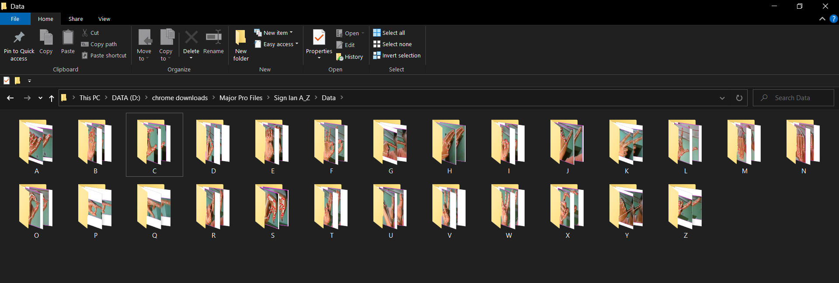

Fig 1 : Sample pictures of training data

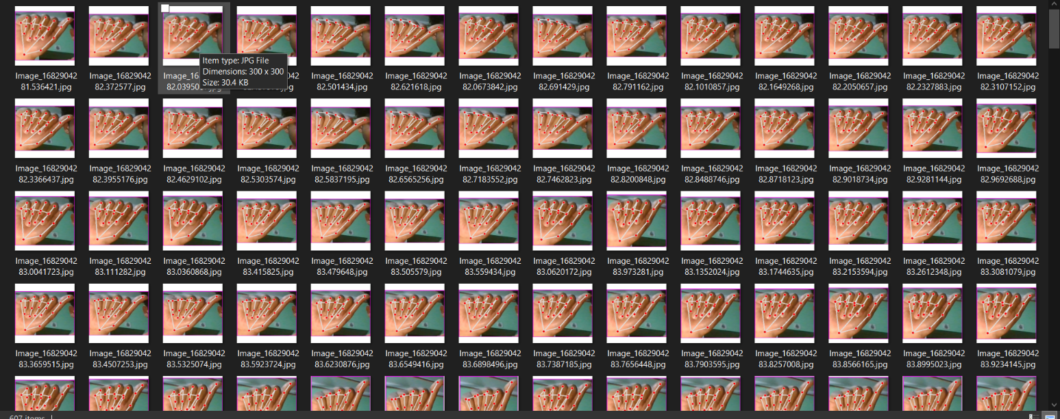

Fig 2 : Training data given for Letter

# **RESULTS AND DISCUSSION**

Tensor Flow models was segregated into 7000 input of training data samples and a testing dataset, similar as

➢ Count of 1500 for each judgment and an incremented as 10,000 for the coming judgment

➢ Data Size be 40

➢ Number of refered layers be 5

➢ Literacy rate could be 0.

➢ Enhances are tf.Keras

➢ Initiatures are tf. Keras.

The trials conducted nearly 20samples, each of having 5 words. Every input from deaf

person is recorded 20 times by changing the trail attempt. Attempt of 20 is redirect into 15 times

for training. The real- time testing conducted for nearlt 50 members. The input Image compared with other distance- grounded classifier algorithms.

Sign language discovery system is evaluated with a system that is based on the methods, rules and methods identified with computational rates, and other factors. The models can be utilised with several sign languages.

The number of attempt being trained and tested for first 4500 and noted. Keras optimizers, and the literacy rate of fine tuning Keras optimizers is noted.

The values of the attributes attained are mentioned in below Table.

|  |  |  |  |  |  |
| --- | --- | --- | --- | --- | --- |
| Learning Rate | Train Loss | Test Loss | Training  Accuracy | Validation  Accuracy | Batch Size |
| 1 | 0.9 | 0.9 | 98.99 | 98.90 | 26 |
| 2 | 0.05 | 0.5 | 99.02 | 99.01 | 26 |
| 3 | 0.05 | 0.5 | 99.89 | 99.07 | 26 |

# **CONCLUSION**

Visual languages known as sign languages use facial expressions, hand and body gestures, and other physical motions to convey meaning. For persons with disabilities to be able to communicate, sign languages are crucial. They are able to share their emotions, communicate, and express themselves via it.TensorFlow's object detection API was used to do it in this study.

The Indian Sign Language alphabet recognition was used to train and. Python and OpenCV were used to collect input images from camera for data gathering. Despite the system's high confidence rate, dataset are trained on certain methods and limitations.

In future, trained data sets maybe increased for accuracy and used for different sign languages.

##### **References**

1) Joudaki & Rehman, Dynamic hand gesture recognition of sign language using geometric features learning.

https//doi.org/10.1504/ijcvr.2022.119239

2) Sharma & Anand, Evaluation of deep models and optimizers for Indian sign language recognition.

https//doi.org/10.1016/j.gvc.2021.200032

3) Wadhawan & Kumar, Deep learning-based sign language recognition system for static signs.

4) Kolivand, Joudaki S, Deep Learning- Based subscribe Language Recognition System for Static Signs and Framework for Language Alphabet Hand Posture Recognition.

5) MohammedA, Lv J, IslamM & Sang Y, Multi-Model Ensemble Gesture Recognition Network for High- Accuracy Dynamic Hand Gesture Recognition.